IT2654 Systems Administration & Security

Tutorial 4

Discuss within your groups and prepare the answers to be presented in class.

- What are the file systems available on Windows Server 2016? Which one would you use when installing the server?
FAT, FAT32, NTFS and ReFS

You need NTFS to install server as it is more stable and has more features (security, RAID, encryption, compression etc). ReFS is quite new, used for big data, need to do testing before implementing. FAT and FAT32 has no security and they have a file size limitation of 4GB.

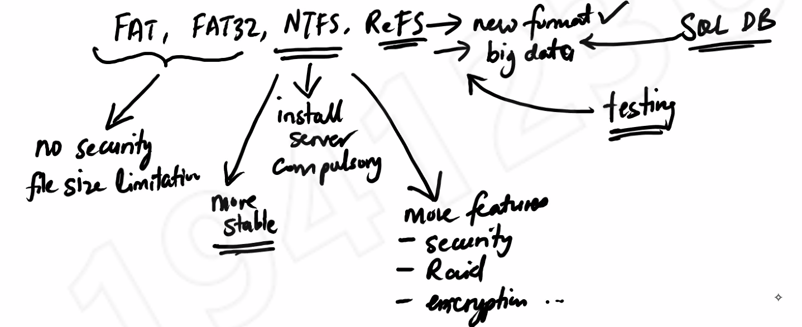

- In what situations would you use FAT32 format?
- Maintain backward compatibility with older Windows operating systems.
  - This means that it will work with an older version of Windows (good for when you’re not sure what kind of Windows is being used on the other person’s side; linux also). FAT format everyone can read (mac, windows, linux).
- Install other operating systems
- Legacy systems support (very old applications)
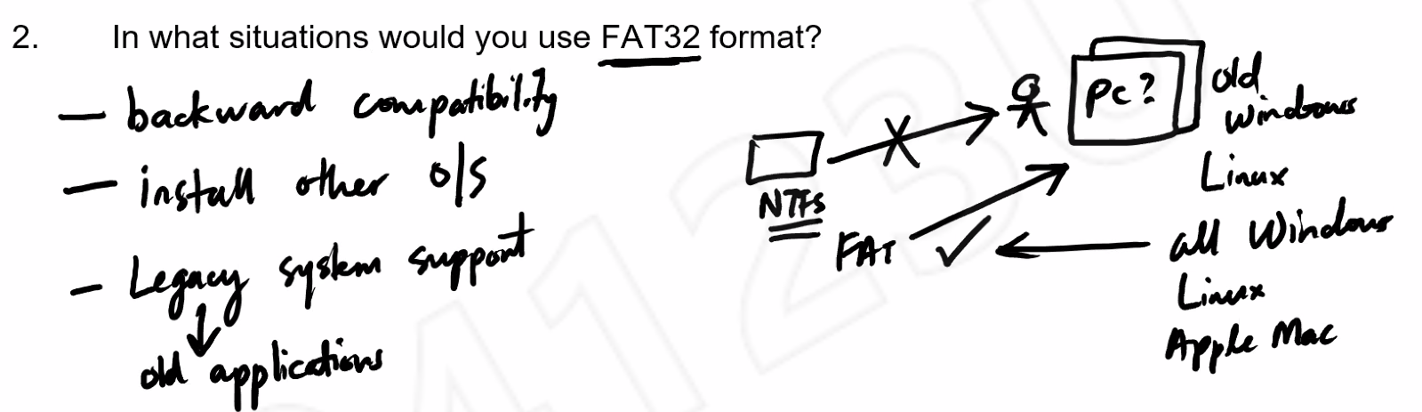
- What is the effective permission rule when you combine NTFS and shared permissions? What is the difference in effective permission when you access a file locally and over a network?
The most restrictive permission applies. If NTFS = read and write and shared= read only, then effective permission is read only.

Locally: only NTFS permission
Over a Network: NTFS + Shared permission
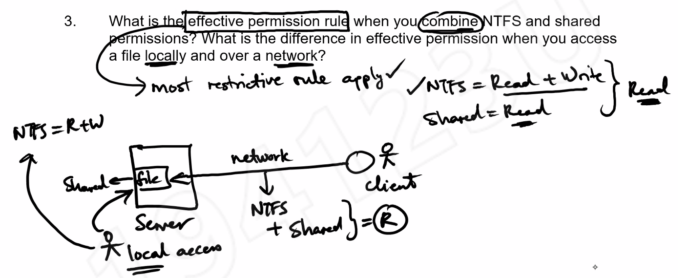
- What are the 4 common file attributes in a Windows system? Describe how the Archive bit is used.
Read only – can’t edit or delete
Hidden – make files and folders less visible to users in file explorer and command line
System – identify OS files in MS DOS, to protect system files
Archive – mark which files and folders have been recently changed or deleted, for backup purposes. 0= backup done, 1= not backed up yet. Types of backup = full backup, incremental backup, differential backup

Hidden + System = Super Hidden

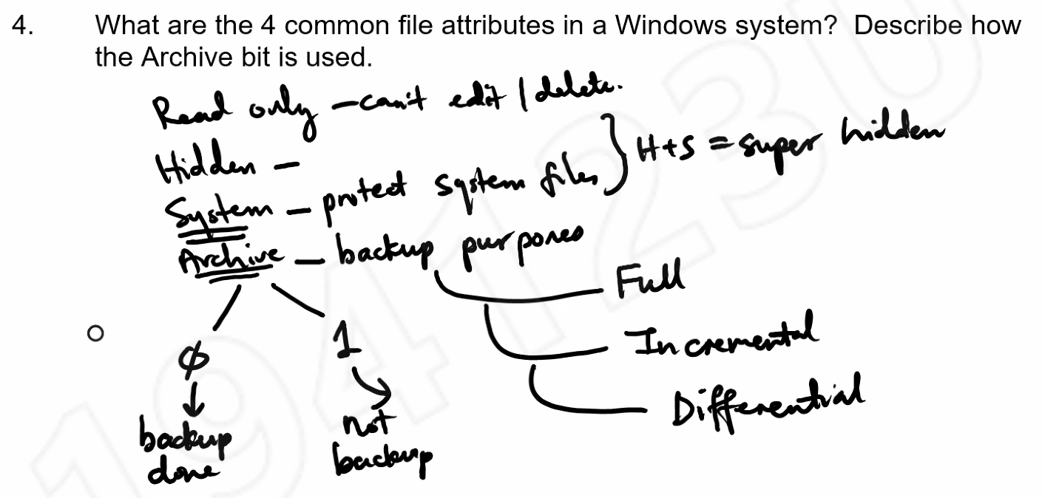
- What is encryption? Describe how Windows implement encryption in Windows Server 2016. What happens to a user’s encrypted files after he/she leaves the company?
It is a way to conceal information by altering it, so it appears to be random data in order to prevent people from seeing the data. If you send plaintext over the network, if there is a hacker somewhere along the way, they will be able to read it. However, once you encrypt it, it will be seen as cipher text so the hacker will need to find a way to decode it more secure.

EFS: need 2 keys private key (user’s password) and public key (Microsoft). So this allows user’s password to decrypt the message.

DRA (Data Recovery Agent) is found inside the server. The administrator is the default DRA so he can decrypt the data. Administrator can grant permissions to other users to allow them to be DRA too.

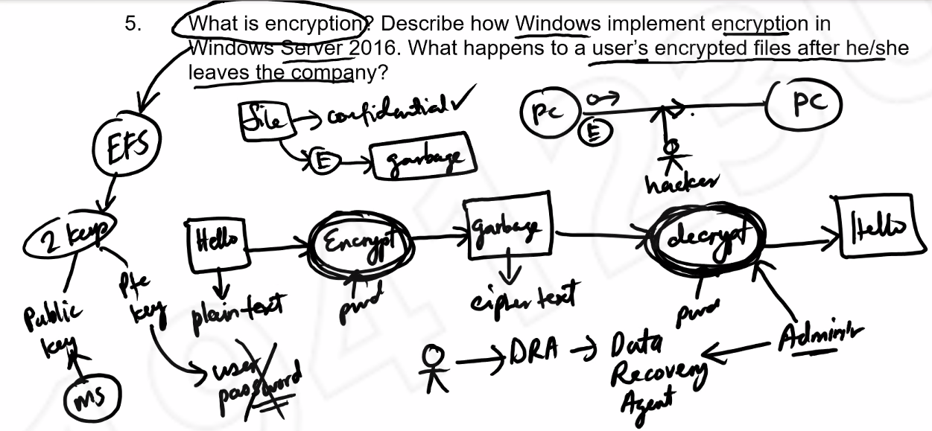

- What is disk quota? How is it implemented in Windows Server?

Disk quotas are a means of controlling the storage space available to Windows users. The storage space is on the server. There is a hard (exceed then prevent writing) and soft quota (exceed then get a warning but can still write)

Use DOS command fsutil or you can go to disk property, under the disk quota tab (but can only configure for users). In the server, you can also use the group policy for users and groups.
